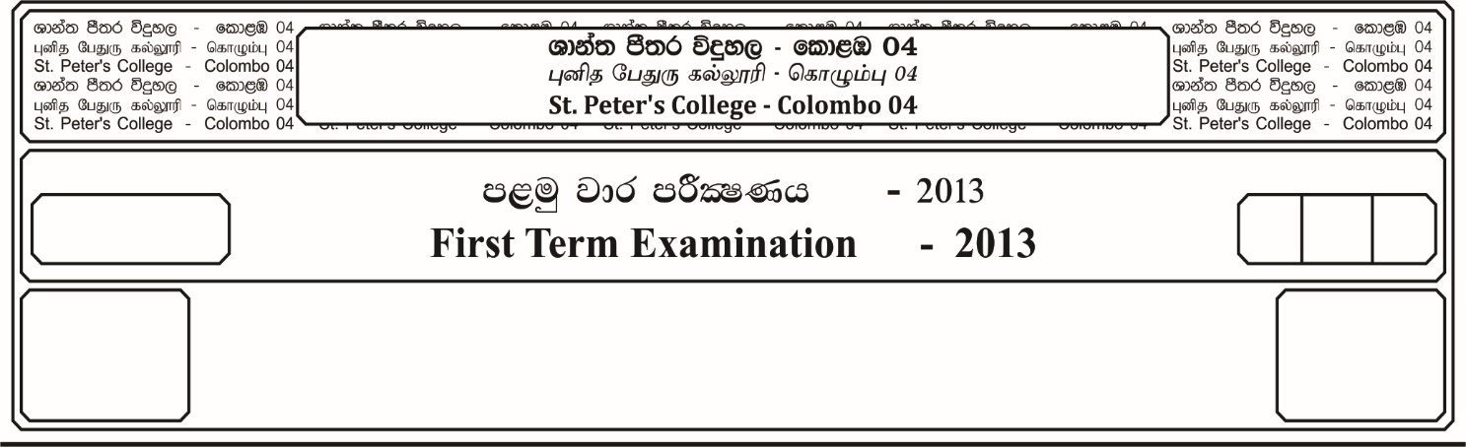

12 fY%aKsh

GRADE 12

E

$2_{2 }^{1}$ meh

$2_{2}^{1}$ Hour

II

**f;jk jdr mÍCIKh - 2022**

**Third Term Examination - 2022**

ixhqla; .Ks;h - ¸¸

**COMBINED MATHEMATICS – II**

10

* **Answer all the questions of *Part - A* and any 04 questions of *Part – B***

**Part – A**

01. Two forces ***P*** and ***Q*** have a resultant ***R*** and the resolved Part of ***R*** in the direction of ***P*** is magnitude ***Q***. Show that the angle between the forces is **2**

02. A body falls from the top of a tower and during the last second of its flight falls $\frac{16}{25}$ of the whole distance. Find the height of the tower.

03. Two uniforms smooth spheres each of radius ***a*** and weight ***W*** lie at rest touching each other inside a fixed smooth hemispherical bowl of radius **3*a***. Show that the reaction between the two spheres is .

60o

45o

Q

N

O

R

04. Three forces ***P***, ***Q*** and ***R*** act on a particle ***O***. If the particle is in equilibrium, then find the values of ***Q*** and ***R***.

05. In the usual notation, thw position vectors of two points ***A*** and ***B***, with respect to fixed origin **O** are $∝\underline{i} + \underline{j}$ and $\underline{i} -2 \underline{j}$. If $A\hat{O}B=90^{o}$, Find the value of .

06. A bullet fired into a target losses half of the velocity, after penetrating 3 cm. Find the distance that it will further penetrate before coming to rest.

07. A uniform ladder of length **2*a*** and weight ***W*** is leaning against a smooth vertical wall, at an angle $∝$ to the horizontal. A man of weight ***W*** climbs up the ladder. Show that if $μ$ $>$ $\frac{3}{4}$**Cot $∝$** the man can reach the top of the ladder. Where $μ$ is the coefficient of the friction.

08. ***P*** and ***Q*** are two ports on the same coast of a river which flows uniformly. A steam boat taken **t1** seconds to move from ***P*** to ***Q*** and **t2** **(> t1)** seconds to move from ***Q*** to ***P***. Show that the time taken by a log of wood to float freely from ***P*** to ***Q*** is $\left(\frac{2 t_{1} t_{2}}{t_{1} - t_{2}}\right)$ seconds.

**Part – B**

* **Answer 04 questions only.**

09. a). A rocket is fired vertically upward from the ground with an acceleration ***10ms-2***. The fuel is finished in one minute and the rocket continue to move up under gravity. Draw velocity-time graph or otherwise find,

i. The maximum height the rocket attains.

ii. The time at which the rocket hits the grounds $\left(g=10{ms}^{-2}\right)$

b). A ship ***A*** sailing with uniform velocity ***20kmh-1*** in the direction of the East observes boat ***B*** approaching it from a direction, ***60o*** North of East. Finf the true velocity of the boat.

10. a). Let and $\underline{b}$ be non-zero non-parallel vectors and $λ$***, $μ$ $ϵ$***  ***R***.

Show that if $\underline{a}+ μ\underline{b}= \underline{0}$, then $λ= 0$ and $μ=0$

The points ***A***, ***B*** and ***C*** have position vectors. $\underline{a}$, $\underline{b}$ and $m\underline{a}+n\underline{b}$ respectively. If ***A***, ***B*** and ***C*** arecollinear, show that ***m + n = 1***

b). Define the scalar product of two vectors $\underline{a}$ and $\underline{b}$.

If ***ABC*** is a right angled triangle, where $\hat{B}={90}^{o}$ By using a vector method prove that,

***AC2 - BC2 = AB2***

c). The diagonals of ***ABCD*** square intersect at ***G***. ***O*** is any point on the plane ***ABCD***. Show that

11. A particle is projected with a velocity ***U*** making an angle $∝$ to with the horizontal, from a point ***O***, to pass a point ***P (x , y)***. ***x*** and ***y*** be the horizontal and vertical distances from ***O***. Show that,

***y* = $x tan x-$ $\frac{1}{2}$ $\frac{{gx}^{2}}{U^{2}}$ ${Sec}^{2}∝$**  , ***g*** is the gravitational acceleration.

When a particle is projected from ***O*** with a velocity ***V*** and angle of projection ***45o*** to the horizontal. It passes through two points each at a height h above the horizontal plane through ***O*** andat a horizontal distance ***“a”*** apart.

Prove that $V^{2}$ **= 2gh + g $\sqrt{{4h}^{2}}+ a^{2}$** .Find also the horizontal range.

12. a). Three forces ${\underline{F}}_{1}$ = $\underline{i}+2\underline{j}$, ${\underline{F}}_{2}$ = $-2\underline{i}+P\underline{j}$ and ${\underline{F}}_{3}$ = $q\underline{i}-4\underline{j}$ act on a particle at ***O***. If the particle is in equilibrium, then find the values of ***p*** and ***q***.

b). ***ABCD*** is a square of side ***a***. Forces of magnitude ***P***, $2P, 3P , 4P$ $8 \sqrt{2} P$ **, $2\sqrt{2} P$**  pact along $\vec{AB}$ **, $\vec{BC}$, $\vec{CD}$, $\vec{DA}$, $\vec{BD}$**  and $\vec{AC}$ respectively. Considering ***AB*** and ***AD*** as ***x*** and ***y*** axes. Find,

i. The magnitude and the direction of the resultant.

ii. The point at which the line of action of the resultant intersects the ***x*** axis.

13. a). State the “Lamis” theorem of three forces.

A smooth hemispherical bowl of internal radius ***r***, is fixed with its rim horizontal. A thin uniform rod of length **l (l < 4*r*)** and weight ***W*** rests with one end inside the bowl and the other end projecting over the rim. If the rod is inclined at an angle $θ$ to the horizontal.

i. Show that **4*r* Cos2 $θ$ = l cos $θ$** .

ii. Find the reactions between the rod and bowl in terms of $θ$ and ***W***.

b). A string ***PQRS*** hangs from fixed points ***P*** and ***S***. Carring a mass of ***12kg*** at ***Q*** and mass ***mkg*** at ***R***. ***PQ*** inclined at ${60}^{o}$ to the horizontal and ***RS*** inclined ${30}^{o}$ the horizontal. ***BC*** is in horizontal. If the system is in equilibrium. Find,

i. The value of ***m***.

ii. Tensions in the strings ***PQ***, ***QR*** and ***RS***.

14. Define the angle of friction.

A uniform rod is placed within a fixed rough verticle circular hoop. If the rod substends an angle of ${60}^{o}$ at the centre of the hoop and the coefficient of friction is $\frac{1}{\sqrt{3}}$, show that in the position of limiting equilibrium the inclination of the rod to the horizontal is $\tan^{-1}$ $\left(\frac{\sqrt{3}}{2}\right)$